

## Unveiling The Virtual Classroom: An In-Depth Analysis Of The

Online Education System

Age(Years) compared to Performance in online by Gender and Your level of satisfaction in Online Education

Age(Years) (Sum) Performance in online (Sum)

Female | Average Female | Bad Female | Good Male | Average Male | Bad Male | Good

Gender - Your level of satisfaction in Online…

0 500 1,000 1,500 2,000 2,500 3,000 3,500 4,000 4,500 5,000 5,500 6,000 6,500

Age(Years) (Sum)

## Unveiling The Virtual Classroom: An In-Depth Analysis Of The Online Education System

Study time (Hours) by Level of Education

10

9 (32.1%) 9 (32.1%)

Study time (Hours) (Count distinct)

10 (35.7%)

8

6

4

2

0

Post Graduate

School

Under Graduate

Level of Education

## Unveiling The Virtual Classroom: An In-Depth Analysis Of The

Online Education System

Internet facility in your locality by Your level of satisfaction in Online Education

Average

Your level of satisfaction in Online Education

Bad Average: 1235

Good

0 200 400 600 800 1,000 1,200 1,400 1,600 1,800 2,000

Internet facility in your locality (Sum)

## Unveiling The Virtual Classroom: An In-Depth Analysis Of The Online Education System

Performance in online by Level of Education

Post Graduate

Level of Education

School

Under Graduate

0 500 1,000 1,500 2,000 2,500 3,000 3,500 4,000 4,500 5,000 5,500

Performance in online (Sum)

7.11

Urban

6.07

Urban

## Unveiling The Virtual Classroom: An In-Depth Analysis Of The

Economic status, Home Location and Performance in online Online Education System

6.68

Urban

Economic status

Home Location

Performance in online

Middle Class

Rural

6.72

**Summary**

6.69

Poor

Rural

6.49

**Summary**

6.37

Rich

Rural

9

**Summary**

7.3

**Summary**

6.7

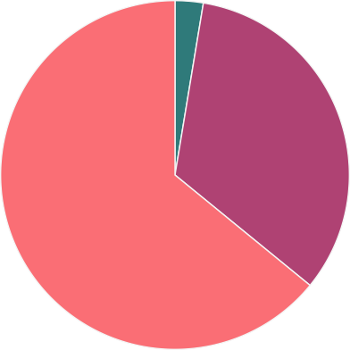

## Unveiling The Virtual Classroom: An In-Depth Analysis Of The

Online Education System

Time spent on social media (Hours) by Device type used to attend classes

Device type used to attend classes

Desktop Mobile Laptop

907

1,746

## Unveiling The Virtual Classroom: An In-Depth Analysis Of The

Online Education System

Engaged in group studies? colored by Engaged in group studies? sized by Performance in online

Performance in on…

2,899 4,018

Engaged in group studies?

No yes



No yes



## Unveiling The Virtual Classroom: An In-Depth Analysis Of The

Online Education System

Average marks scored before pandemic in traditional classroom sized by Average marks scored before pandemic in traditional classroom

Average marks sc…

1 343

61-70

81-90 71-80

91-100

## Unveiling The Virtual Classroom: An In-Depth Analysis Of The Online Education System

Your level of satisfaction in Online Education

# Good

Average

Bad



Unveiling The Virtual Classroom: An In-Depth Analysis Of The

Device type used to attend classes, Gender

Online Education System

Gender (Count dis…

2 2

Laptop

Mobile

Desktop

